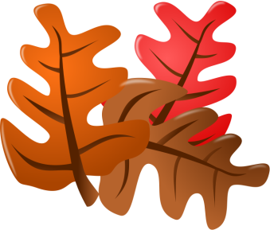
Bury Art Society
Autumn Newsletter
2017

Programme
Once again Derek White has produced a very interesting and challenging programme accompanied by the illustrated explanatory booklet. Hopefully everyone will “have a go” at the items and subjects on offer each week, although everyone is welcome to “do their own thing” in the rear studio to continue their own work in progress. As long as everyone enjoys the evenings and the camaraderie of a shared interest in art which has always been the ethos of the Society.
Members
We have already had enquiries from about five or six people wishing to become members and following existing policy, have invited them to come along to a couple of our meetings before committing themselves to membership. Most of the enquiries have come to the secretary via our website. We hope they approve of us and what is on offer!
Book Cupboard
Shock and horror – the book cupboard had disappeared. Problem now solved, the College caretaker has promised to replace it in the Studio for our next meeting. A full list of the books which are available will be circulated shortly.
Coach Trips
The trip arranged by Bernice Davenport to the Lady Lever Gallery was a great success. Bernice and Pam Stone are now in the process of considering future venues and dates for 2018. The procedure will once again be on the principal of seats for “first come, first served” with payment of the full cost up front. The outings will be a combination of visits and sketching/painting, further details will be circulated in the New Year.
Annual Exhibition
The exhibition at Bury Art Museum this year opens on Saturday 2nd December and runs until 3rd February. Full details will be circulated to everyone well in advance. Alongside the exhibition the Gallery are presenting “Retrospective of a Travelling Artist” showcasing the life’s–work of our President, David Swithenbank inspired by his extensive travels in Europe and through India.
There is also a project “Bury Art Society: Archiving People and Place”
Annual Competition
The subject for this year’s light-hearted competition will be announced at the Christmas Social evening on 18th December.
NWFAS
The North West Federation of Art Societies have decided that there will be no more meetings held on a regular basis and unless new officers are appointed, will cease to exist. The Art Society has already discontinued membership.

It has been my sad duty to report that Mary Shaw, a stalwart and much-loved, hardworking member of the Society, passed away on the 20th September. She will be sadly missed. Our thoughts and sympathy have been passed on to Mary’s family.
Peggy Hargreaves
Secretary

